A000-ME-Bactria-Margiana-Mother Goddess Crowned and Seated with Two Deities and Inscription-6000 BCE

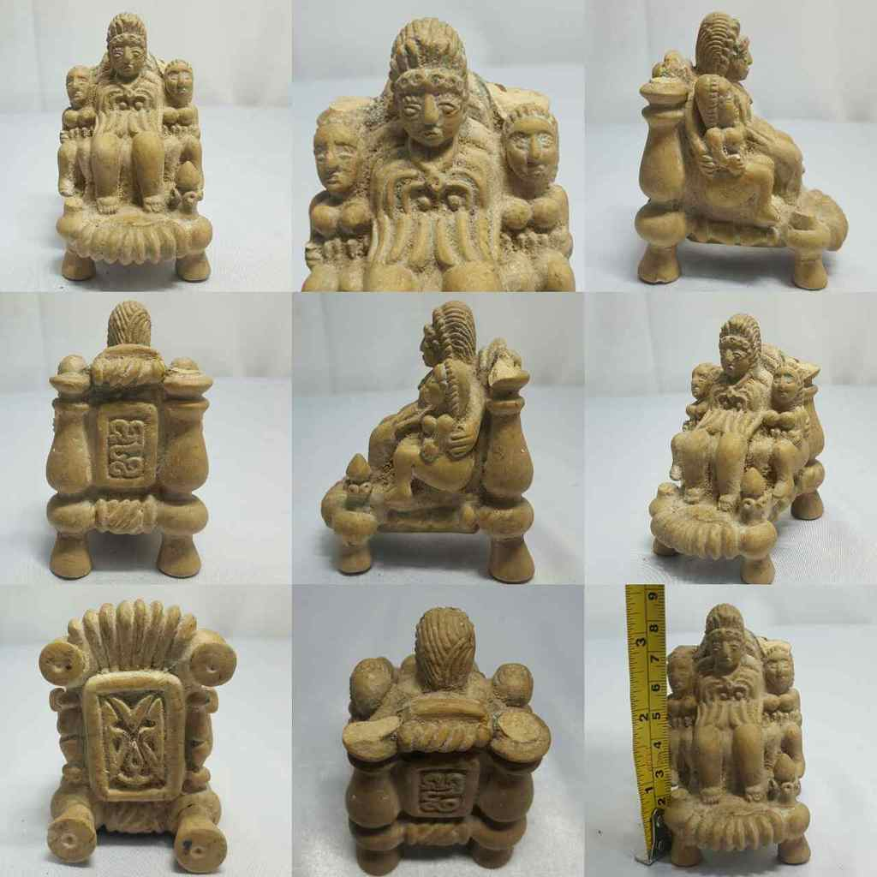

Figs. 1-9. Bactria-Margiana-Mother Goddess Crowned and Seated with Two Deities and Inscription-6000 BCE

Case No. 3.

Formal Label: Bactria-Margiana-Mother Goddess Crowned and Seated with Two Deities and Inscription-6000 BCE

Display

Accession Number: GN778.32.A3

Date or Time Horizon: Middle to Late Bronze Age, 2000-1650 BCE

Geographical Area: Afghanistan

Cultural Affiliation: BMAC (Oxus)

Medium: silicified sandstone

Dimensions: H 9 X W 7 C M

Weight:

Condition: Finials on throne are missing

Provenance: [vintage.intaglio](http://www.ebay.com/usr/vintage.intaglio?_trksid=p2047675.l2559), Thailand

**References:**

**Discussion:**

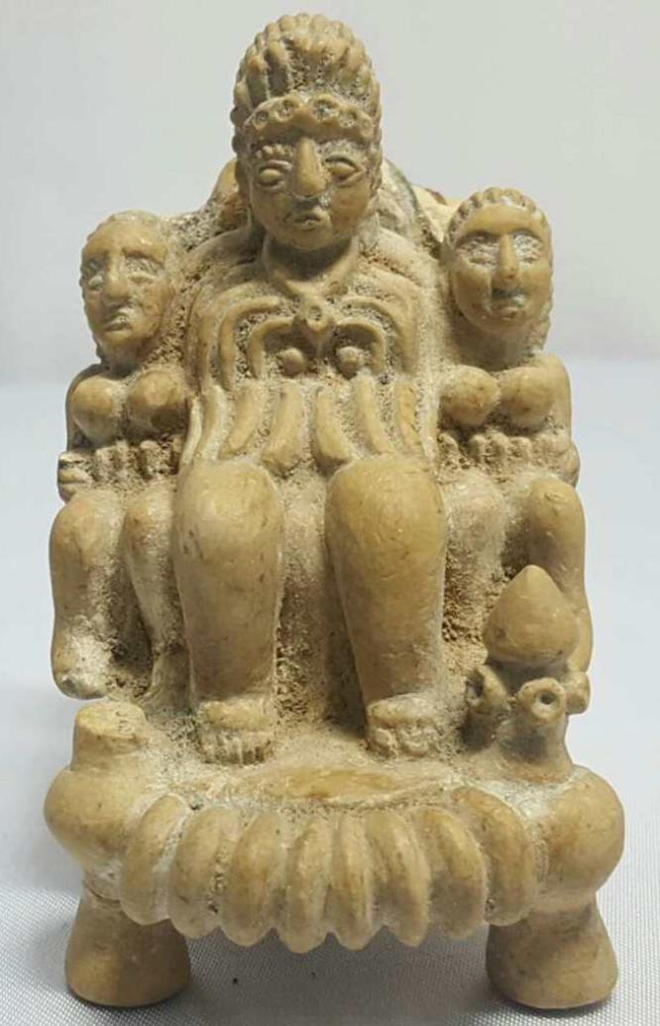

#### [RARE ANCIENT BACTRIAN 3 IDOL WORSHIP FIGURES STONE STATUE](http://www.ebay.com/itm/282280912207)

|  |  |
| --- | --- |
| Item price | $315.00 |
| Quantity | 1 |
| Item number | 282280912207 |
| Shipping service | Economy Shipping from outside US |

## Shipping address

Ralph J Coffman Jr

149 Atlantic Ave

Swampscott MA 01907-2427

United States

## Order total

|  |  |
| --- | --- |
| Subtotal | $1,513.90 |
| Shipping | $27.00 |

**Total**

$1,540.90